באדיבות איתי גולן ואתר

<https://www.eewiki.net/pages/viewpage.action?pageId=4096079>

בקובץ יש שינויים, שעשה איתי כי הקובץ באתר הזה לא עובד בצורה מושלמת.

מצורף רכיב LCD

**הסבר על הכניסות:**

כניסת clk - מקבלת שעון של 50 מגה הרץ

כניסת reset_N - ריסוט אסינכרוני (פעיל בנמוך - '0')

כניסת lcd_bus - מקבלת את האות להדפסה (לפי הטבלה שמצורפת למטה)

כניסת lcd_enable - פולס אשר מאפשר דגימה - במידה ורוצים להדפיס את האות שנמצאת כרגע ב lcd_bus מעלים את הסיגנל lcd_enable למשך זמן מחזור אחד.

**הקצאת הדקים:**

   ;##############################################

   ;# Alfanumeric LCD display not including data #

   ;##############################################

   ;# using the HD44780 controller

   ;# read_writeN

   ;##LCD_RW

   set_location_assignment PIN_K4 -to rw

   ;# Enable (LCD_EN)

   set_location_assignment PIN_K3 -to e

   ;# register select (LCD_RS)

   set_location_assignment PIN_K1 -to rs

   ;# data BUS (LCD_DATA)

   set_location_assignment PIN_J1 -to lcd_data[0]

   set_location_assignment PIN_J2 -to lcd_data[1]

   set_location_assignment PIN_H1 -to lcd_data[2]

   set_location_assignment PIN_H2 -to lcd_data[3]

   set_location_assignment PIN_J4 -to lcd_data[4]

   set_location_assignment PIN_J3 -to lcd_data[5]

   set_location_assignment PIN_H4 -to lcd_data[6]

   set_location_assignment PIN_H3 -to lcd_data[7]

   ;# LCD Power ON/OFF (LCD_ON)

   set_location_assignment PIN_L4 -to pwr

   ;# LCD Back Light ON/OFF (LCD_BLON)

   set_location_assignment PIN_K2 -to bkpwr

* + [Attachments (12)](https://www.eewiki.net/pages/viewpageattachments.action?pageId=4096079)
  + [Page History](https://www.eewiki.net/pages/viewpreviousversions.action?pageId=4096079)
  + [Restrictions](https://www.eewiki.net/pages/viewinfo.action?pageId=4096079)
  + [Page Information](https://www.eewiki.net/pages/viewinfo.action?pageId=4096079)
  + [Resolved comments (0)](https://www.eewiki.net/pages/viewpage.action?pageId=4096079)
  + [Link to this Page…](https://www.eewiki.net/pages/viewinfo.action?pageId=4096079)
  + [View in Hierarchy](https://www.eewiki.net/pages/listpages-dirview.action?key=LOGIC&openId=4096079#selectedPageInHierarchy)
  + [View Source](https://www.eewiki.net/plugins/viewsource/viewpagesrc.action?pageId=4096079)
  + [Export to PDF](https://www.eewiki.net/spaces/flyingpdf/pdfpageexport.action?pageId=4096079)
  + [Export to Word](https://www.eewiki.net/exportword?pageId=4096079)



1. [Logic](https://www.eewiki.net/display/LOGIC?src=breadcrumbs-homepage)
2. [Home](https://www.eewiki.net/display/LOGIC/Home?src=breadcrumbs-parent)

[Character LCD Module Controller (VHDL)](https://www.eewiki.net/pages/viewpage.action?pageId=4096079)

[Skip to end of metadata](https://www.eewiki.net/pages/viewpage.action?pageId=4096079#page-metadata-end)

* [https://www.eewiki.net/download/resources/com.atlassian.confluence.plugins.confluence-page-banner:page-banner-resources/images/red_padlock.png](https://www.eewiki.net/pages/viewpage.action?pageId=4096079)
* [https://www.eewiki.net/download/resources/com.atlassian.confluence.plugins.confluence-page-banner:page-banner-resources/images/grey_attach.png](https://www.eewiki.net/pages/viewpageattachments.action?pageId=4096079&metadataLink=true)
* Created by [Scott Larson](https://www.eewiki.net/display/~scott.larson@digikey.com), last modified on [Aug 01, 2013](https://www.eewiki.net/pages/diffpagesbyversion.action?pageId=4096079&selectedPageVersions=34&selectedPageVersions=35)

[Go to start of metadata](https://www.eewiki.net/pages/viewpage.action?pageId=4096079#page-metadata-start)



* [Code Download](https://www.eewiki.net/pages/viewpage.action?pageId=4096079#CharacterLCDModuleController(VHDL)-CodeDownload)
* [Introduction](https://www.eewiki.net/pages/viewpage.action?pageId=4096079#CharacterLCDModuleController(VHDL)-Introduction)
* [State Machine](https://www.eewiki.net/pages/viewpage.action?pageId=4096079#CharacterLCDModuleController(VHDL)-StateMachine)
* [Port Descriptions](https://www.eewiki.net/pages/viewpage.action?pageId=4096079#CharacterLCDModuleController(VHDL)-PortDescriptions)
* [Initialization](https://www.eewiki.net/pages/viewpage.action?pageId=4096079#CharacterLCDModuleController(VHDL)-Initialization)
* [Transactions](https://www.eewiki.net/pages/viewpage.action?pageId=4096079#CharacterLCDModuleController(VHDL)-Transactions)
* [Conclusion](https://www.eewiki.net/pages/viewpage.action?pageId=4096079#CharacterLCDModuleController(VHDL)-Conclusion)
* [Additional Information](https://www.eewiki.net/pages/viewpage.action?pageId=4096079#CharacterLCDModuleController(VHDL)-AdditionalInformation)
* [Feedback for Our Sponsor](https://www.eewiki.net/pages/viewpage.action?pageId=4096079#CharacterLCDModuleController(VHDL)-FeedbackforOurSponsor)

Code Download

Version 2.0:  [lcd_controller.vhd](https://www.eewiki.net/download/attachments/4096079/lcd_controller.vhd?version=3&modificationDate=1339620193283&api=v2)

Version 1.0 is no longer available.

Example that instantiates the lcd_controller.vhd component and uses it to write "123456789" to an lcd module:  [lcd_example.vhd](https://www.eewiki.net/download/attachments/4096079/lcd_example.vhd?version=2&modificationDate=1339620261643&api=v2)

Introduction

This LCD controller is a VHDL component for use in CPLDs and FPGAs.  The controller manages the initialization and data flow to HD44780 compatible 8-bit interface character LCD modules.  It was primarily developed pursuant to the Lumex LCD General Information datasheet.  This example VHDL component allows simple LCD integration into practically any programmable logic application.  Figure 1 depicts the controller implemented to interface between an LCD module and a user’s custom logic.

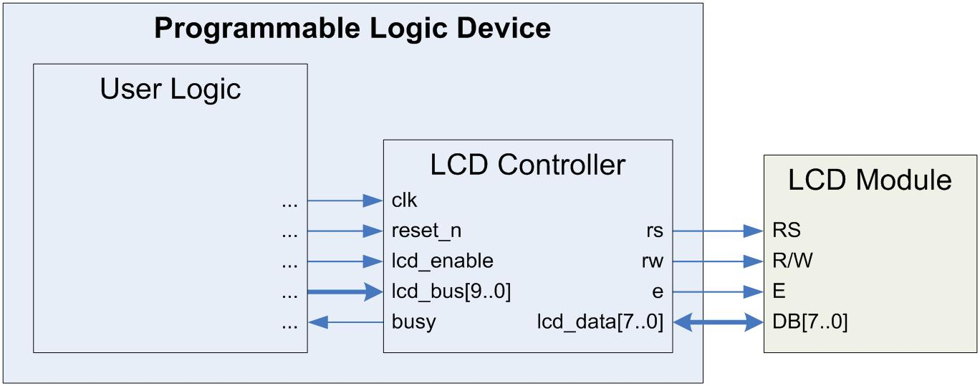

**Figure 1.**  LCD Controller Implementation in PLD

State Machine

The LCD controller state machine consists of five states.  Upon startup, it immediately enters the Power-up state, where it waits 50ms to ensure the supply voltage has stabilized.  It then proceeds to an Initialize state.  The controller cycles the LCD through its initialization sequence, setting the LCD’s parameters to default values defined in the hardware.  This process completes in approximately 2.2ms, and the controller subsequently assumes a Ready state.  It waits in this state until the lcd_enable input is asserted, then advances to the Send state.  Here, it communicates the appropriate information to the LCD, as defined by the lcd_bus input.  After 50us, it returns to the Ready state until further notice.  If a low logic level is applied to the reset_n input at any time for a minimum of one clock cycle, the controller resets to the Power-up state and re-initializes.  Figure 2 illustrates the LCD controller state machine.

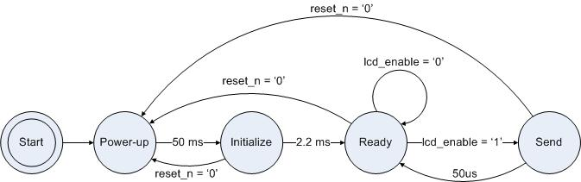  
**Figure 2.**  LCD Controller State Machine

Port Descriptions

Table 1 describes the LCD controller’s interface.

**Table 1.**  LCD Controller I/O Description

| **I/O Name** | **Width** | **Mode** | **Description** | **Interface** |
| --- | --- | --- | --- | --- |
| clk | 1 | input | Clock for LCD controller.  Default set for 50MHz.  If a different frequency is desired, change the constant freq in the architecture declarations to reflect the new frequency in MHz. | system clock |
| reset_n | 1 | input | Active low synchronous reset pin.  This pin must be set high to implement the LCD controller.  Setting the pin low for one or more clock cycles restarts the LCD controller state machine. | user logic |
| lcd_enable | 1 | input | Data latch for LCD controller.  H: initiates a transaction using the data currently on the lcd_bus, L: no transaction is initiated and any data on lcd_bus is ignored | user logic |
| lcd_bus | 10 | input | Data/instructions to be sent to the LCD module.  The MSB is the rs signal, followed by the rw signal.  The other 8 bits are the data bits.  The LSB on the bus corresponds to the least significant data bit. | user logic |
| busy | 1 | output | Feedback on the state of the LCD controller.  H: the controller is busy initializing or conducting a transaction with the LCD module, any instructions/data sent will be ignored, L: the controller is idle and ready to accept commands for a transaction | user logic |
| rs | 1 | output | LCD module Register Select Signal; H: sending data, L: sending instructions | LCD pin 4 |
| rw | 1 | output | LCD module Read/Write Select Signal; H: Read, L: Write | LCD pin 5 |
| e | 1 | output | LCD module enable signal | LCD pin 6 |
| lcd_data | 8 | bidir | Data bus to the LCD module / busy signal from the LCD | LCD pins 7-14 |

Initialization

The LCD controller executes an initialization sequence each time it is powered-up or the reset_n pin is deasserted for a minimum of one clock cycle.  The controller asserts the busy pin during initialization.  Once initialization completes, the busy pin deasserts, and the LCD controller waits in the Ready state for input from the user logic.

The initialization sequence specifies several LCD parameters:  function, display control, display clear, and entry mode.  The LCD controller instantiates the following default set of these options.

* Function Set:  2-line mode, display on
* Display Control:  display on, cursor off, blink off
* Entry Mode:  increment mode, entire shift off

The user can send commands to the LCD to change any parameters after initialization.  Alternatively, the user can edit the VHDL to change the default parameters.  This simply requires commenting out the current VHDL line and uncommenting the line with the desired parameter setting.  Table 2 lists the options available in the code.

**Table 2.**  Initialization Options in the VHDL

| **Options** | **Choices** | **VHDL Line** | **Code** |
| --- | --- | --- | --- |
| Function Set | 2-line mode, display on* | 93 | lcd_data <= "00111100"; |
|  | 1-line mode, display on | 94 | lcd_data <= "00110100"; |
|  | 1-line mode, display off | 95 | lcd_data <= "00110000"; |
|  | 2-line mode, display off | 96 | lcd_data <= "00111000"; |
| Display ON/OFF | display on, cursor off, blink off* | 104 | lcd_data <= "00001100"; |
|  | display on, cursor off, blink on | 105 | lcd_data <= "00001101"; |
|  | display on, cursor on, blink off | 106 | lcd_data <= "00001110"; |
|  | display on, cursor on, blink on | 107 | lcd_data <= "00001111"; |
|  | display off, cursor off, blink off | 108 | lcd_data <= "00001000"; |
|  | display off, cursor off, blink on | 109 | lcd_data <= "00001001"; |
|  | display off, cursor on, blink off | 110 | lcd_data <= "00001010"; |
|  | display off, cursor on, blink on | 111 | lcd_data <= "00001011"; |
| Entry Mode Set | increment mode, entire shift off* | 127 | lcd_data <= "00000110"; |
|  | increment mode, entire shift on | 128 | lcd_data <= "00000111"; |
|  | decrement mode, entire shift off | 129 | lcd_data <= "00000100"; |
|  | decrement mode, entire shift on | 130 | lcd_data <= "00000101"; |

* denotes default choice

Transactions

Upon deassertion of the busy pin, the LCD controller enters the Ready state.  The user logic can interface via the lcd_enable and lcd_bus pins to conduct transactions with the LCD module.  The user initiates this process by issuing the desired data/instruction to the lcd_bus and asserting the lcd_enable pin.  The LCD controller then asserts the busy pin and manages the transaction.  When finished, the controller deasserts the busy pin, indicating that it is ready for another instruction.  Figure 3 depicts the timing diagram for the beginning of a transaction.

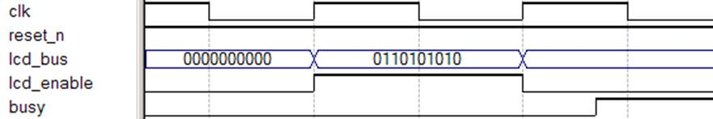

**Figure 3.**  Transaction Timing Diagram

Conclusion

The LCD control logic provided manages the initialization and data flow between custom user logic and the 8-bit interface mode of HD44780 compatible character LCD modules.  The user can set the system clock frequency in the architecture declarations and change the default initialization parameters by selecting which VHDL lines to uncomment.

Additional Information

[LCD General Information; Lumex, Inc.](https://www.eewiki.net/download/attachments/4096079/lumex_lcd_information.pdf?version=1&modificationDate=1343228756397&api=v2)

[HD44780U (LCD-II); Hitachi, Ltd.](https://www.eewiki.net/download/attachments/4096079/HD44780.pdf?version=1&modificationDate=1343228591517&api=v2)

Feedback for Our Sponsor

Please take a few seconds to help us justify the continued development and expansion of the eewiki.

Click on one of our [Digi-Key](http://www.digikey.com/) links on your way to search for or purchase electronic components.

Is the eewiki helpful?  Comments, feedback, and questions can be sent to [eewiki@digikey.com](mailto:eewiki@digikey.com).

[wangyue2725](https://www.eewiki.net/display/~fangying) likes this

* No labels

